**Gated Recurrent Unit Based Deep Learning Model For Bitcoin Price Prediction**

*1Radha Mohan Pattanayak  
VIT-AP University  
Amaravathi, Andhra Pradesh-522237  
[radhamohan.pattanayak@gmail.com](mailto:radhamohan.pattanayak@gmail.com)

4Sivapuram Tarun Vivek  
VIT-AP University  
Amaravathi, Andhra Pradesh-522237  
tarunvivek.21bce9342@vitapstudent.ac.in 2Mungili Chetan Sai Raju  
VIT-AP University  
Amaravathi, Andhra Pradesh-522237  
chetansai.21bce9409@vitapstudent.ac.in

5Jakka Subramanya Rithwik  
VIT-AP University  
Amaravathi, Andhra Pradesh-522237  
[rithwik.21bce9028@vitapstudent.ac.in](mailto:rithwik.21bce9028@vitapstudent.ac.in)

3Veerapu Vishnu  
VIT-AP University  
Amaravathi, Andhra Pradesh-522237   
vishnu.21bce9254@vitapstudent.ac.in

Corresponding Author: Radha Mohan Pattanayak

*Abstract* - Over the years, the fluctuations of price of Bitcoin creates many challenges for the data scientists and market investors in predicting the accurate price of bitcoin. In past, many researchers have implemented different models to predict the price of Bitcoin, but still it is required improvement in accurate prediction. In the present study, we proposed the Gated Recurrent Unit (GRU) model to forecast the accurate price of bitcoin. All the models are experimented using the Yahoo Finance dataset, and the performance of the proposed GRU model is explored with six different deep learning models as Additive Prophet, Multiplicative Prophet, Bidirectional Long Short-Term Memory (BiLSTM), CatBooster, Support Vector Regression (SVR), and hybrid GRU 1D-CNN. The model evaluation is performed based on various metrics such as Mean Absolute Error (MAE), Root Mean Square Error (RMSE), and R² score. From the experimental analysis it is observed that, the performance of the GRU model is outperformed over it’s counterparts and produced better result with more prediction reliability.

Keywords— Cryptocurrency, Bitcoin price prediction, Facebook Prophet, LSTM (Long Short-Term Memory), Hybrid models (GRU 1D-CNN, GRU), Categorical Boosting (CatBooster), Support Vector Regression (SVR)

# Introduction

A virtual currency named Bitcoin has been created to be used as money and a mode of payment without the necessity of any individual, organization, or group. The concept of Bitcoin was developed in 2009 and later it became the most well-known cryptocurrency globally. The rise in popularity of Bitcoin resulted in the development of numerous alternative cryptocurrency models such as Ethereum, Cardano, Dogecoin, and many more. Due to Bitcoin's popularity, its price has become volatile and challenging to predict. The price of Bitcoin is very hard to estimate because it is highly volatile and the price is affected by many factors [1, 2]. These factors include global economic conditions and monetary policy combined with events unique to Bitcoin itself like regulatory shifts, technological developments, and market emotion. The decentralized and often speculative character of Bitcoin trading makes the prediction of its price more complicated which leads to an excellent environment for the development of new forecasting techniques.

The traditional methods such as Generalized Autoregressive Conditional Heteroskedasticity (GARCH) and Auto-Regressive Integrated Moving Average (ARIMA) [3], these are widely applied in financial markets using time series forecasting. However, these models cannot explain the unique features of Bitcoin, due to its non-stationarity, erratic cycles and sharp price swings. This has forced researchers to consider even more advanced methods that are likely to be better prepared to handle the high complexity and nonlinearity [4] in the time series data can handle the fluctuations of the Bitcoin price more efficiently. These methods can capture complex patterns in both historical data and external factors like market sentiment.

In this study, we aim to compare the performance of several state-of-the-art models for Bitcoin price prediction, including Additive Prophet, Multiplicative Prophet, BiLSTM, GRU, hybrid GRU 1D-CNN, CatBooster, and SVR. By conducting a thorough comparison, this research provides valuable insights into the GRU model.

The proposed GRU model increases it’s forecasting performance of the bitcoin price in both trading as well as in forecasting areas by offering a robust short-term predictive capabilities for highly volatile assets like bitcoin. It provides enhanced forecasting accuracy as the GRU model can handle non-linear sequential data efficiently. It reduces computational cost for real-time predictions compared to LSTM because of fewer parameters and is computationally less intensive which allows faster processing capability. By offering reliable price predictions. The proposed GRU model can contribute more robust risk management strategies through this model traders can leverage these forecasts to set up maximizing their returns and make trading seamless based on predicted price movements. With the GRU model financial institutions can deploy predictive tools capable of handling high frequency training scenarios effectively.

The work adds to this expanding corpus of research into the prediction of cryptocurrency prices and provides valuable insights into the real-world. The results of this study are expected to have implications for the development of price-prediction models by researchers and practitioners targeting other young and volatile markets, not just traders and investors who try to sail through the erratic Bitcoin market.

The rest of the paper is organized as follows: section 2 presents the related work. Section 3 introduces the proposed GRU model and its architecture. Section 4 presents the results and discussion and finally, section 5 concludes the paper with some future suggestion.

# RELATED WORK

Ramani et al. [5] considers various models such as LSTM, SVM,1D CNN, CATBoost, and Prophet with and without considering sentiment analysis to predict the Bitcoin price. They have considered the Yahoo finance API and real-time tweets and news articles for sentimental analysis. When the sentiment analysis was not considered, Prophet has the lowest MAE but got a high RMSE. However, when the sentiment analysis was considered the LSTM model became the best performing model along with RMSE. The remaining models ARIMA and XGBoost showed slight improvements while Prophet’s accuracy decreased with sentiment analysis.

In 2023, the Shimpi et al.[6] proposed a ML framework using LSTM and consider the sentiment analysis to predict the Bitcoin prices. The LSTM model captured price trends, combined with Twitter sentiment analysis to reflect market sentiment. The dependency on Twitter sentiment data that can be biased and it needs for continuous model updates for accuracy.

Some other concepts like a Centralized Clusters Distribution (CCD) and a Weighted Empirical Stretching (WES) loss function, challenging the target of extreme bimodality in the distribution of Bitcoin price. Time-series decomposition techniques like Singular Spectrum Analysis (SSA), Empirical Mode Decomposition (EMD), and Variational Mode Decomposition (VMD) are also incorporated to capture trends and improve accuracy. A significant improvement was achieved in results with an 11.5% reduction in RMSE across the entire distribution and 22.5% in extreme regions [7]. CCD-WES when combined with the LSTM model and decomposition methods outperformed baseline models mainly in bimodal-distributed and volatile data. The model's dependency on specific hyperparameters and continues tuning for optimal performance is a drawback.

A hybrid framework was used for the prediction of Bitcoin price combining signal processing techniques, feature selection, and deep neural networks optimized with Bayesian methods [8]. A 3-step feature selection is done using the Boruta method filters which filter relevant indicators, preprocessing of data involves outlier detection with the Hampel filter, and noise smoothing with the Savitzky-Golay filter. The Deep Artificial Neural Network (DANN) with technical indicators excels and has achieved a minimal absolute error of 0.28% for one-day forecasts and 2.25% for seven-day forecasts. Advantages include robust feature selection and noise reduction techniques whereas high model complexity and reliance on specific input features is a drawback.

An analysis was done on the high-frequency cost sites of 80 fluid cryptocurrencies over 21 months utilizing q-dependent detrended cross-correlation examination [9]. This technique is outlined to handle the non-stationary nature of cryptocurrency time arrangement. The investigation recognized contrasts in showcase behavior amid calm versus turbulent periods, permitting the confinement of little and expansive change impacts. The comes about appeared that advertise centralization expanded over time, with major resources like BTC and ETH acting as center points, particularly amid brief time scales. Exceptionally, cryptocurrency promoting remained more independent compared to customary markets, without a doubt in the midst of significantly associated periods. In spite of some methodological restrictions such as data quality and test appraisal, considering given beneficial encounters into the progressing structure and stream of the cryptocurrency grandstand. The study is limited to focusing on finance data and without exploring the high-frequency fluctuations.

During the period spanning August 2015 to March 2018, an investigation was conducted to delve into how Bitcoin [10], Ethereum, Litecoin, and Dashcoin all moved together. This exploration was carried out through the lens of wavelet analysis. Through the employment of both Wavelet Multiple Correlation and Cross-Correlation techniques, it became apparent that Bitcoin might just be the frontrunner in the market. Here Bitcoin stands out as the lead dancer whose steps sway the rest into motion. Drawing from the findings it comes to light that when Bitcoin climbs the price ladder other digital currencies hustle to catch up. The research included multi-scale insights in detail while the limitation is the lack of broader asset diversification and focus on only short-to-medium-term patterns.

An investigation was done in which the researchers delved into how the wavering economic policies of China during the tumultuous COVID-19 era [11] have influenced the performance of Bitcoin. Everyday data between the last day of December 2019 and the 20th of May 2020 is used for Ordinary Least Squares and Generalized Quantile Regression methods to conduct their analysis. Discoveries uncover that when China encounters strong approach vulnerability Bitcoin tends to perform way better, particularly within the beat levels. This focuses on the plausibility of Bitcoin being a dependable protection in times of extraordinary arrangement disarray. Advantages include its use of advanced econometric methods and its focus on China, a major Bitcoin mining hub. One of the drawbacks is discussing a narrow timeframe (pandemic-only data), limiting broader applicability, and failing to account for non-pandemic economic factors. Research backs up the idea that Bitcoin acts like a safe place for money letting those who invest spread their risks when the economy looks shaky.

A research was done where they turned machine learning techniques to predict Bitcoin prices by analyzing patterns over time along with complex features gathered from various data points. The data was collected from online resources. Key methods included the likes of Artificial Neural Networks ANN Stacked ANN SANN Support Vector Machines SVM and the advanced Long Short-Term Memory LSTM systems. To tackle the challenge of simplifying data the methods of choice involved using Random Forest alongside statistical techniques ensuring a more manageable analysis process. LSTM results were the most accurate with around 65% classification accuracy and errors ranging from 1.44% (MAPE) about the next day to 4.10% off for those looking 90 days ahead [12]. Some limitations arise during classification accuracy due to Bitcoin's unpredictable fluctuations whereas improved prediction accuracy over existing models and robustness in high-volatility intervals is an advantage.

A forecasting method for Bitcoin price using the FbProphet model is used [16], describing the challenges of cryptocurrency's volatile nature. The study applies descriptive and exploratory data analysis (EDA) on historical Bitcoin data. The FbProphet has been chosen for its advantageous nature of handling multiple seasonality factors, missing data, and large outliers when compared to LSTM and ARIMA models which struggled with Bitcoin’s dynamic trends. The FbProphet model has given better performance than the LSTM and ARIMA models showing higher accuracy and lower error rates considering RMSE and MAPE. One of the limitations is that Fbprophet’s performance can be affected by inconsistent or rapidly shifting patterns. The conclusion of the paper is that FbProphet is ideal for cryptocurrency price prediction due to its flexibility and future work can combine sentiment analysis and real-time big data tools to enhance prediction accurately.

A deep learning model was used for the prediction of Bitcoin’s closing price for the next day using a hybrid model that combines 2D Convolution Neural Networks (CNN) and Long Short Term Memory (LSTM). The LSTM captures temporal dependencies while 2D-CNN extracts spatial features with hyperparameter tuning using the OPTUNA framework for optimization of performance. The model was trained using 85% of pre-processed data from historical Bitcoin data from Coinbase API including features such as RSI. A dropout layer was added to avoid overfitting. The hybrid model has given better performance than the traditional models like GRU, LSTM, and CNN achieving an R² score of 0.9816 and MAPE of 0.034 [17]. The real-time prediction is supported by the system and is suitable for fast decision-making. Some advantages of the model are enhanced interpretability, reduced sensitivity to outliers, and support for trend shift whereas some of the drawbacks are the unpredictability of the cryptocurrency market, where sudden changes can affect accuracy.

Joshila et al. [22] proposed the SVM for predicting Bitcoin prices. The data for Bitcoin prices was collected over two years from sources such as investing.com and coin-desk.com with features like opening price, closing price, and date while irrelevant data was cleared. The preprocessed data included removing null values and standardizing price data across currencies. The model, SVM was taken into choice for its efficiency in reducing time and space complexity in comparison with CNN and Random Forest models. The SVM model outperforms alternatives in speed and space complexity and achieves 70% accuracy [22], making it advantageous for prediction, while the drawback is it may falter under political influences​.

Daily data consists of high-dimensional features such as market capitalization, mining difficulty, and Google trends whereas 5-minute data focuses on some basic trading features such as open, close, and volume. Few models such as Logistic Regression, XGBoost, SVM, and Random Forest were applied the Logistic Regression model achieved the best results for daily price prediction (64.84% accuracy) whereas XGBoost excelled in high-frequency data (59.4% accuracy) [26].

# PrOPOSED METHODOLOGY

In this study, we implemented the RNN network called Gated Recurrent Unit for predicting the Bitcoin prices and compared the results to the other models which are Facebook prophet multiplicative and additive, BiLSTM, SVR, Hybrid 1D-CNN GRU, and CatBooster models [13]. The implementation of the GRU model and its workflow is described in the Figure [1]:

Bitcoin coin price Data Collection  
(from Yahoo finance)

Preprocessing the data

Splitting the data into training and testing

Define the GRU Model

Training the model with dataset.

Model Evaluation

Fig 1: Work Flow of GRU Model

* 1. **Algorithm:** The proposed GRU Model

1. Download the dataset that is made ready to use till up to data from “yfinance”.
2. Preprocess the data like removing the null values in the data, extracting relevant column names, etc.
3. Normalize the y-column values using MinmaxScaler to bring the values in the range (0,1) using the equation [1]:
$$\begin{aligned}ScaledValues=\frac{value-min}{\max{- min}} \#\left( seq equation 1\right)\end{aligned}$$

4. Create input-output pairs, each input X is a sequence of normalized prices, and the output Y is the next price.
5. Split the data into training and testing in the ratio of 70:30 as one dataset and also 80:20 as one dataset.
6. Define a GRU-based neural network model with two layers of GRU architecture and one dense layer for final prediction prices output using the equation [2]. $$\begin{aligned}h\left(t\right)=GRU\left(X,h\left(t-1\right)\right)\#\left( seq equation 2\right)\end{aligned}$$
7. Train the model using the Adam optimizer and MSE loss function using the equation [3]:
$$\begin{aligned}MSE=\frac{1}{n}\sum_{i=1}^{n}{{\left(xi-\hat{xi}\right)}^{2}} \#\left( seq equation 3\right)\end{aligned}$$

8. Now train the model by fitting the model parameters like batch size of 32 and train for 1000 epochs.
9. Now test the trained model using training data. We used model evaluation metrics like Root mean square error (RMSE) using equation [4], Mean Absolute Error(MAE) using equation [5], and R2 score using equation [6]:
$$\begin{aligned}RMSE= \sqrt{\frac{1}{n}\sum_{i=1}^{n}{{\left(xi-\hat{xi}\right)}^{2}}} \#\left( seq equation 4\right)\end{aligned}$$

$$\begin{aligned}MAE= \frac{1}{n}\sum_{i=1}^{n}{\left|xi-\hat{xi}\right|} \#\left( seq equation 5\right)\end{aligned}$$

$$\begin{aligned}R^{2}=1- \frac{\sum{{\left(xi-\hat{xi}\right)}^{2}}}{\sum{{\left(xi-\overline{xi}\right)}^{2}}} \#\left( seq equation 6\right)\end{aligned}$$

10. Now define the function for predicting the future values of the bitcoin prices, starting with the last available sequence in the dataset. Update the sequence with predicted prices for each future prediction.
11. Finally plot the results of both training and testing data as well as the future predicted values of the test data on the same graph using data visualization libraries like Matplotlib.
12. END

## **GRU**

The main purpose of GRU is to address the limitations of the recurrent neural network like the vanishing gradient problem. It is closely related to just like LSTMs whereas GRUs are very fast and simpler than the LSTMs. GRUs simplify the internal architecture of LSTM by merging the forget gate and input gate into one as an update gate [14]. Due to this, it controls the flow of information by selecting only the relevant information and by forgetting the irrelevant information. This makes GRU a very efficient model for handling sequential data and is used for time series predictions and natural language processing.

**Architecture of GRU**

Coming to the architecture of gated recurrent units it uses a gated mechanism to selectively update the hidden state at each time stamp. It contains two gates which control the flow of information in and out of the network [15].

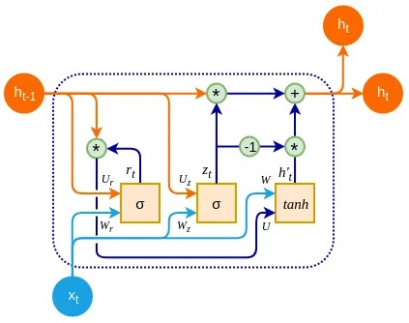

Fig 2: GRU Architecture

The overall complex architecture of the GRU model is shown in the figure [2]. Breaking down in a small and concise way, each GRU cell has two inputs, one is the previous hidden state data and the other is the input in the current timestamp. In each time stamp the cell combines both inputs and passes through an update gate and reset gate. Then the output data is again passed through a dense layer with SoftMax activation function to make the predictions. By doing this repeatedly, the entire inputted data will finally give the required outputs. The actual dataflow of the GRU model is shown in figure [3].

Hidden state(ht-1)

Input(xt)

Reset Gate

Output(yt)

New hidden state(ht-1)

Update Gate

Fig 3: Data flow in GRU

**Reset Gate**: this gate decides how much amount of past information is to be kept and how much should be forgotten. In other words, it decides whether the past information should be completely forgotten or not so that can be used for calculating the hidden state values.

The result given by the reset gate is r(t). the weight associated with input x(t) is W(r) and to previous hidden state h(t-1) is U(r). the sigmoid function of these two values is the output of the reset gate as defined in equation [7].

$\begin{aligned} r\left(t\right)=σ\left(W^{\left(r\right)}*x\left(t\right)+U^{\left(r\right)}*h\left(t-1\right)\right)\#\left( seq equation 7\right)\end{aligned}$

**Update Gate:** this gate decides how much amount of new input should be used to calculate the hidden state values. It decides what proportion of old information and what proportion of new information should be kept and allowed for calculations.

The results produced by the update gate is Z(t). the weight associated with input x(t) is W(z) and to previous hidden state h(t-1) is U(z). the sigmoid function of these two values is the output of the update gate as defined in equation [8].

$$\begin{aligned}Z\left(t\right)=σ\left(W^{\left(z\right)}*x\left(t\right)+U^{\left(z\right)}*h\left(t-1\right)\right) \#\left( seq equation 8\right)\end{aligned}$$

**Candidate Hidden State:** this is calculated using the data produced from the reset gate. This information is used to determine the information stored from the past. This is generally the memory buffer in the GRU cell. This is calculated using the following equation.

The outputs of the candidate hidden state h(t) is calculated using the equation [9], where W and U are weights of input and hidden state and x(t) and r(t) are input and reset gate values. h(t-1) is the the values of previous hidden state value.

$$\begin{aligned}h\left(t\right)=tanh\left(W*x\left(t\right)+r\left(t\right)⨀ U^{\left(z\right)}*h\left(t-1\right)\right) \#\left(9\right)\end{aligned}$$

## **Facebook-Prophet**

Facebook Prophet model is a tool developed by the Team of Facebook company, especially for forecasting time series data [14, 15]. It is designed for cases where there will be very high irregularities in seasonal component data trends.

1. **Additive Prophet Model:**

**Description:** The additive model is appropriate when the seasonal effects and trend variations are relatively constant over time. This model represents a particular observation in time series as the sum of four components trend, seasonality, holiday effects and random error as given in equation [10].

$$\begin{aligned}y\left(t\right)= Trend\left(t\right)+Sesonality\left(t\right)+Holiday\left(t\right)+Error\left(t\right)\#\left(10\right)\end{aligned}$$

1. **Multiplicative Model:**

**Description:** The multiplicative model makes the assumption that the forecast may be generated by multiplying the effects of trends, holidays, and seasonality on the time series data. This model represents a particular observation in time series data as the product of four components trend, seasonality, holiday effects and random error as given in equation [11].

$$\begin{aligned}y\left(t\right)= Trend\left(t\right)*Sesonality\left(t\right)*Holiday\left(t\right)*Error\left(t\right)\#\left(11\right)\end{aligned}$$

## **Bi-LSTM**

Bi-LSTM or bidirectional Long Short Term Memory is an updated version of LSTM [18,19] is a type of Recurrent neural network.

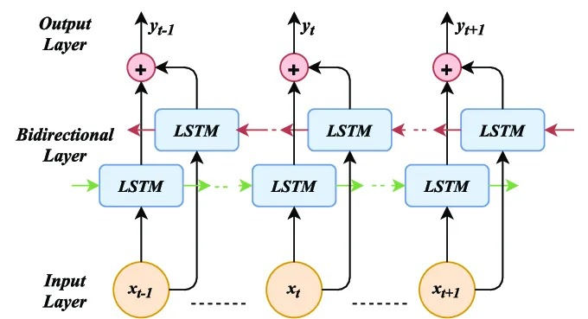

Fig 4: BiLSTM

The figure [4] shows that the model processes the sequential data in both forward and backward directions. It means it processes the input data in both directions, allowing it to capture information from both the past and future of the data sequence.

## **1D-CNN**

In this method, there will be a one-dimensional convolutional filer also called Kernal will slide across the input sequence [20, 21]. This filter sets the learnable weights that the network adjusts during training. The convolution operations include multiplying the values of the filter by the original input values in a segment of the sequence finally summing up the results to produce a single output point. This process is repeated across the input sequence generating a transformed sequence as output.

## **SVR**

Support Vector Regression is a variation of traditional support vector machine which is adapted for regression problems. In the research authors [22, 23, 24, 25] have been used the SVM model to predict the continuous time series data to predict the future value. This model aims to find the function that approximates the data within a certain margin of error while keeping the model as simple as possible. Here SVR aims to predict the future price of the bitcoin based on the historical price data and other features like trading volume, market sentiment, or external events.

## **CatBooster**

CatBooster which is also known as Categorical Boosting, is an open-source gradient boosting algorithm developed by Yandex to forecast the unstable bitcoin prices. The author [26] considered this model to forecast the bitcoin price and observed that this model is good at handling categorical features without any extra preprocessing steps

# RESULTS AND DISCUSSIONS

This section presents the comparison of results of all the six different deep learning models along with the proposed GRU model. The Yahoo finance dataset has considered for the performance evaluation of all models. The concept of normalization of the data converts different features into a similar and smaller scale, so it reduces the risk of bias from large variations in feature values and allow the network model to converge more efficiently. In the present research, we considered the MinMax Scaler for the normalization which scales the data into a specific range of (0, 1). The dataset is splited into training and testing set. The first 70% instances are considered for training and the rest 30% instances of the dataset are considered for testing the performance of the model. The stopping criteria of all the models are set to 1000 epochs. The input sequence length is considered 30 for all the forecasting model including the proposed GRU model to forecast the future value. In the present research we have considered one step ahead forecasting. The learning rate of the proposed GRU model is optimized using adam optimizer. Three different accuracy measures such as RMSE, MAE, and R2 are considered to measure the performance of all the comparative model including the proposed GRU model.

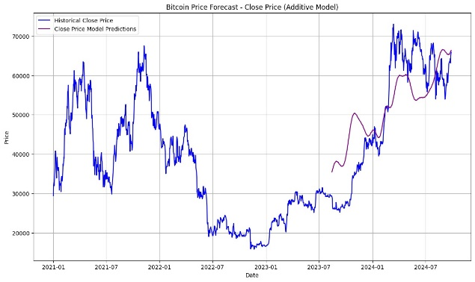

Fig 5: Additive Prophet

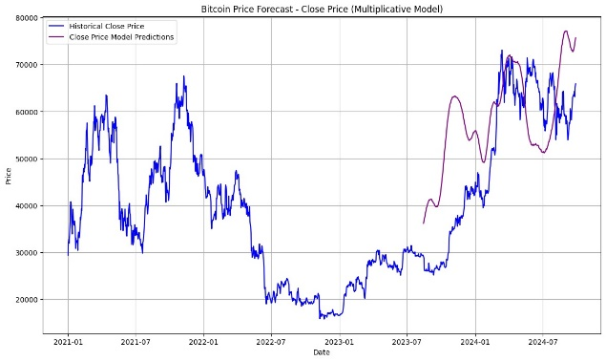

Fig 6: Multiplicative Prophet

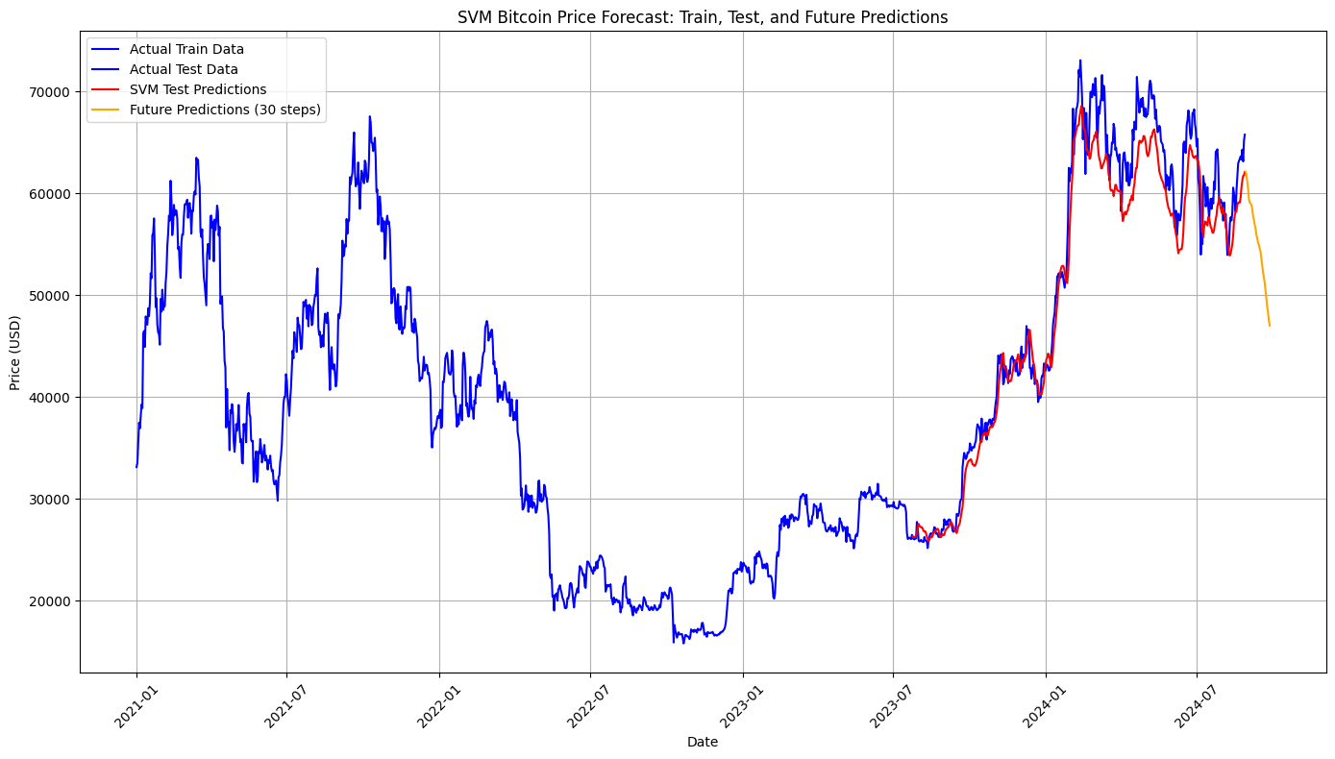

Fig 7: SVR

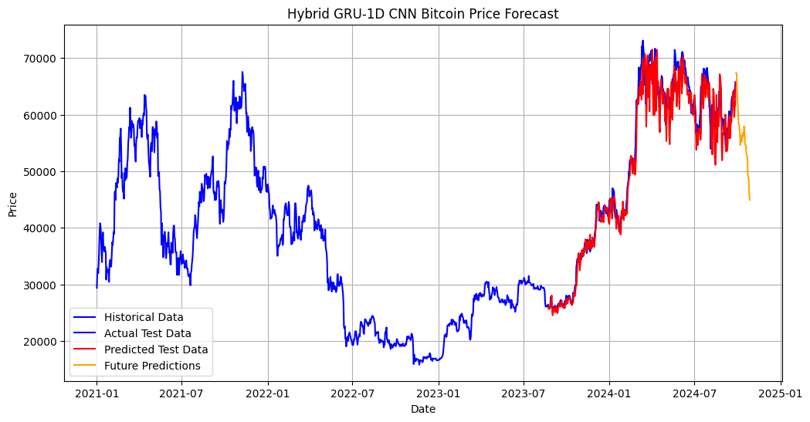

Fig 8: Hybrid GRU 1D-CNN

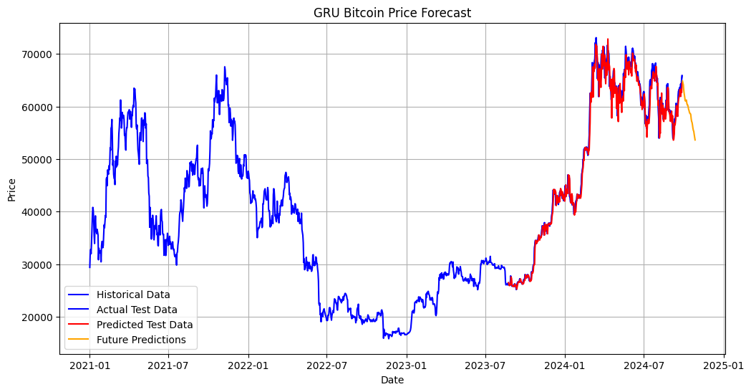

Fig 9: GRU

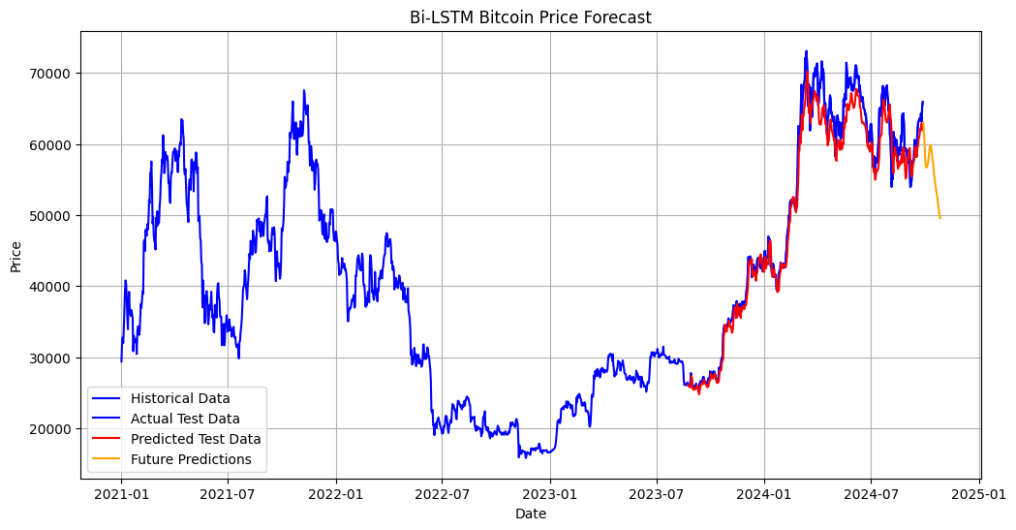

Fig 10: BiLSTM

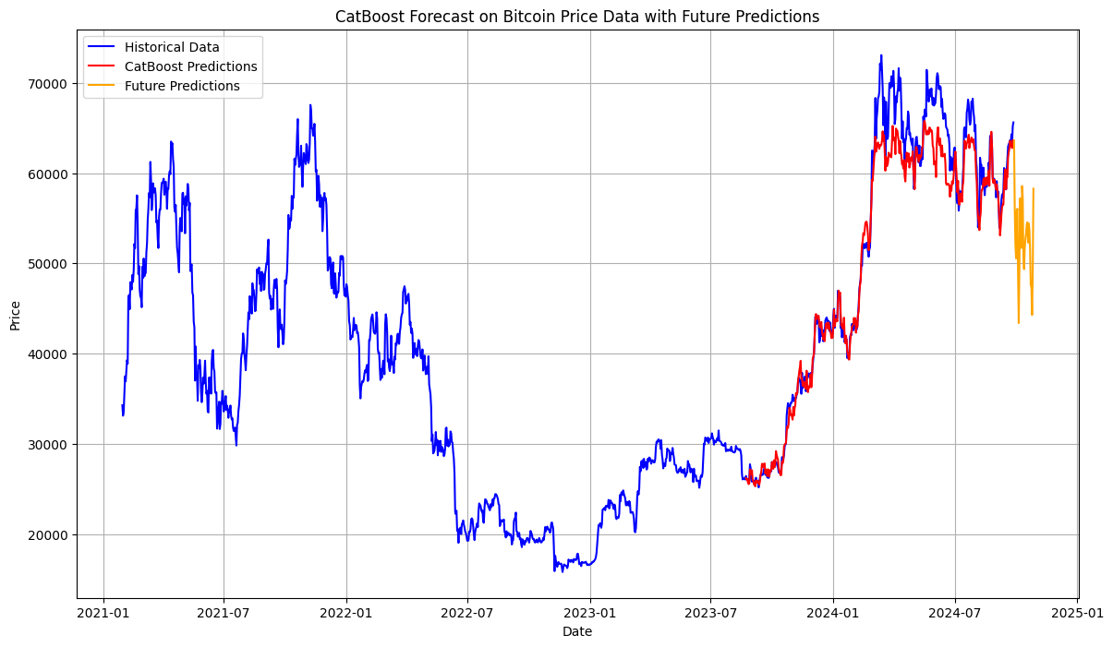

Fig 11: CatBooster

|  |  |  |  |
| --- | --- | --- | --- |
| Models | RMSE | MAE | R² |
| BiLSTM | 2447.09 | 1826.27 | 0.972 |
| GRU | 1728.90 | 1165.68 | 0.986 |
| GRU 1D-CNN | 2784.06 | 1962.50 | 0.964 |
| SVM | 2986.32 | 2290.85 | 0.959 |
| CatBooster | 2839.33 | 1887.70 | 0.963 |
| Additive Prophet | 9513.85 | 8044.03 | 0.603 |
| Multiplicative Prophet | 14202.74 | 12332.68 | 0.116 |

Table 1: Evaluation Metrics (0.7 train & 0.3 test)

The proposed GRU model and all the comparative models are experimented using Python 3.8, Jupyter notebook, Google Colab, AWS EC2 with GPU and Windows 11 platform.

The experimental analysis from table 1 it is observed that the proposed GRU model obtain 1728.90 value in RMSE measure while the Additive Prophet, Multiplicative Prophet, BiLSTM, GRU 1D-CNN, SVM, and CatBooster holds the value as 9513.85, 14202.74, 2447.09, 2784.06, 2986.32, and 2839.33 respectively. According to MAE measure the proposed GRU model obtain 1165.68 value while the Additive Prophet, Multiplicative Prophet, BiLSTM, GRU 1D-CNN, SVM, and CatBooster yields the value as 8044.03, 12332.68, 1826.27, 1962.50, 2290.85, and 1837.70 respectively. The low RMSE and MAE measures of the proposed GRU model indicates clearly the dominance over other comparative models. Apart from this we analysed the performance of all models with R2 value. As per the result from table 1, the R2 value of the proposed GRU model is 0.986 while the Additive Prophet, Multiplicative Prophet, BiLSTM, GRU 1D-CNN, SVM, and CatBooster considered 0.603, 0.116, 0.972, 0.964, 0.959, and 0.963 respectively. The higher R2 value of the proposed model reflects the ability to generalize well to unseen data, and which makes it most accurate among the tested models. Based on the result analysis, it is observed that the proposed GRU model is outperformed it’s comparators in all three measures, while the performance of the Additive Prophet, Multiplicative Prophet model is worse among all models. The large discrepancy value in all measures highlights the challenges of using the Prophet models for highly volatile time series data like Bitcoin. The Figure [5 to 11] shows the actual and predicted values of different forecasting models on the Yahoo finance time series data.

# Conclusion

The price trend of Bitcoin has substantial volatility and complexity. The present study proposed the GRU model to forecast the Bitcoin price considering the Yahoo finance dataset. The proposed GRU model modifies the performance of the bitcoin price prediction algorithms in both trading and also financial forecasting areas by offering robust short-term predictive capabilities for highly volatile assets like bitcoin. The experimental result notifies the performance of the GRU model beat other comparative models with lowest RMSE and MAE value and high R2 value, which signifies its reliability in forecasting the Bitcoin price. The hybrid model GRU-1D CNN performed second highest after GRU in the analysis table, which indicates that the model combinations can also improve the performance results in forecasting. Improved accuracy in predicting prices can provide a good deed to traders with better entry and exit indications which allows low risks and high profits in trading. Due to lesser parameters used in the GRU model it reduces the computational cost for real time predictions compared to the LSTM model which allows faster processing capability. The entire study concentrates only on historical price data and ignore the external elements like market mood, global events, and economic indicators which may affect the Bitcoin price value on forecasting time. The forecasting performance of the model may vary depending on market conditions particularly during the periods of excessive volatility. Future studies might look at more complex hybrid models and incorporate additional data sources including sentiment analysis, macroeconomic variables, and transaction volume, to increase the forecast accuracy and resilience.

##### References

1. Badea, L., & Mungiu-Pupӑzan, M. C. (2021). The economic and environmental impact of bitcoin. IEEE access, 9, 48091-48104
2. Badertscher, C., Maurer, U., Tschudi, D., & Zikas, V. (2024). Bitcoin as a transaction ledger: A composable treatment. Journal of Cryptology, 37(2), 18.
3. Panigrahi, S., Pattanayak, R. M., Sethy, P. K., & Behera, S. K. (2021). Forecasting of sunspot time series using a hybridization of ARIMA, ETS and SVM methods. Solar Physics, 296(1), 6.
4. Pattanayak, R. M., Behera, H. S., & Panigrahi, S. (2019, August). A novel hybrid differential evolution-PSNN for fuzzy time series forecasting. In Computational Intelligence in Data Mining: Proceedings of the International Conference on ICCIDM 2018 (pp. 675-687). Singapore: Springer Singapore.
5. Ramani, K., Jahnavi, M., Reddy, P. J., VenkataChakravarthi, P., Meghanath, P., & Imran, S. K. (2023, March). Prediction of bitcoin price through LSTM, ARIMA, XGBoost, prophet and sentiment analysis on dynamic streaming data. In *2023 9th International Conference on Advanced Computing and Communication Systems (ICACCS)* (Vol. 1, pp. 1514-1518). IEEE.
6. Shimpi, A., Gambhir, R., Diwa-e, A., Udawant, S., Siddiqui, N. Y., & William, P. (2023, June). Framework for Assessment of Bitcoin Price Prediction Using Ensembling Machine Learning Approach. In *2023 3rd International Conference on Pervasive Computing and Social Networking (ICPCSN)* (pp. 349-353). IEEE.
7. Koo, E., & Kim, G. (2024). Centralized decomposition approach in LSTM for Bitcoin price prediction. *Expert Systems with Applications*, *237*, 121401.
8. Tripathi, B., & Sharma, R. K. (2023). Modeling bitcoin prices using signal processing methods, bayesian optimization, and deep neural networks. *Computational Economics*, *62*(4), 1919-1945.
9. Kwapień, J., Wątorek, M., & Drożdż, S. (2021). Cryptocurrency market consolidation in 2020–2021. *Entropy*, *23*(12), 1674.
10. S Kumar, A., & Ajaz, T. (2019). Co-movement in crypto-currency markets: evidences from wavelet analysis. *Financial Innovation*, *5*(1), 1-17.
11. Chen, T., Lau, C. K. M., Cheema, S., & Koo, C. K. (2021). Economic policy uncertainty in China and bitcoin returns: evidence from the COVID-19 period. *Frontiers in Public Health*, *9*, 651051.
12. Mudassir, M., Bennbaia, S., Unal, D., & Hammoudeh, M. (2020). Time-series forecasting of Bitcoin prices using high-dimensional features: a machine learning approach. *Neural computing and applications*, 1-15.
13. Hamayel, M. J., & Owda, A. Y. (2021). A novel cryptocurrency price prediction model using GRU, LSTM and bi-LSTM machine learning algorithms. *Ai*, *2*(4), 477-496.
14. Chen, J. (2023). Analysis of bitcoin price prediction using machine learning. *Journal of Risk and Financial Management*, *16*(1), 51.
15. Alsubai, S., Dutta, A. K., Alghayadh, F., Alamer, B. H., Pattanayak, R. M., Ramesh, J. V. N., & Mohanty, S. N. (2024). Design of Artificial Intelligence Driven Crowd Density Analysis for Sustainable Smart Cities. IEEE Access.
16. Rathore, R. K., Mishra, D., Mehra, P. S., Pal, O., Hashim, A. S., Shapi'i, A., ... & Shutaywi, M. (2022). Real-world model for bitcoin price prediction. *Information Processing & Management*, *59*(4), 102968.
17. Noviandy, T. R., Maulana, A., Idroes, G. M., Suhendra, R., Adam, M., Rusyana, A., & Sofyan, H. (2023). Deep learning-based bitcoin price forecasting using neural prophet. *Ekonomikalia Journal of Economics*, *1*(1), 19-25.
18. Ahmed, O. M., Haji, L. M., Ahmed, A. M., & Salih, N. M. (2023). Bitcoin Price Prediction using the Hybrid Convolutional Recurrent Model Architecture. *Engineering, Technology & Applied Science Research*, *13*(5), 11735-11738.
19. Pattanayak, R. M., Sangameswar, M. V., Vodnala, D., & Das, H. (2022). Fuzzy time series forecasting approach using lstm model. Computación y Sistemas, 26(1), 485-492.
20. Kazeminia, S., Sajedi, H., & Arjmand, M. (2023, May). Real-Time Bitcoin Price Prediction Using Hybrid 2D-CNN LSTM Model. In *2023 9th International Conference on Web Research (ICWR)* (pp. 173-178). IEEE.
21. Sinha, M., Paul, S., Ghosh, M., Mohanty, S. N., & Pattanayak, R. M. (2024). Automated Lunar Crater Identification with Chandrayaan-2 TMC-2 Images using Deep Convolutional Neural Networks. Scientific Reports, 14(1), 8231.
22. Joshila, G. L., Nandini, D. U., & Kalaiarasi, G. (2021, June). Price prediction of bitcoin. In *2021 5th International Conference on Trends in Electronics and Informatics (ICOEI)* (pp. 113-116). IEEE.
23. Pattanayak, R. M., Panigrahi, S., & Behera, H. S. (2020). High-order fuzzy time series forecasting by using membership values along with data and support vector machine. Arabian Journal for Science and Engineering, 45(12), 10311-10325.
24. Pattanayak, R. M., Behera, H. S., & Panigrahi, S. (2021). A novel probabilistic intuitionistic fuzzy set based model for high order fuzzy time series forecasting. Engineering Applications of Artificial Intelligence, 99, 104136.
25. Pattanayak, R. M., Behera, H. S., & Panigrahi, S. (2023). A novel high order hesitant fuzzy time series forecasting by using mean aggregated membership value with support vector machine. Information Sciences, 626, 494-523.
26. Ranjan, S., Kayal, P., & Saraf, M. (2023). Bitcoin price prediction: A machine learning sample dimension approach. *Computational Economics*, *61*(4), 1617-1636.